Algebra 3-4 Name: ______________________

Block: _____
Level 2
Identify the domain and range.
Then tell whether the relation is a function.

1. {(3, 2), (-2, 5), (1, 0), (-4, 6), (7, -1)}

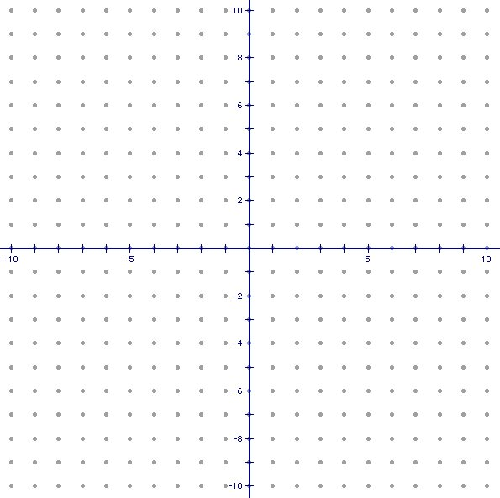
2.

Level 3

Write the equation for the line.

3. m=2 and (-3, 5)

4. (3, -4) and (-2, 6)

Level 4

5. One day your family goes out to pick strawberries.
At 9:00am, your family has picked 3 quarts.
Your family finishes picking at 3:00pm and has
28 quarts of strawberries, stopping only 1 hour for lunch.
At what rate was your family picking strawberries?

